Data Mining
Lab 01

Names:
- Ahmed Mohamed EL-Bawab (08)
- Khalil Ismail Khalil (23)

- Number of instances = 2310 instances.
- Number of attributes = 19 attributes.
- Number of classes = 7 classes.

1)Data Exploration:

1)Histograms:

1)
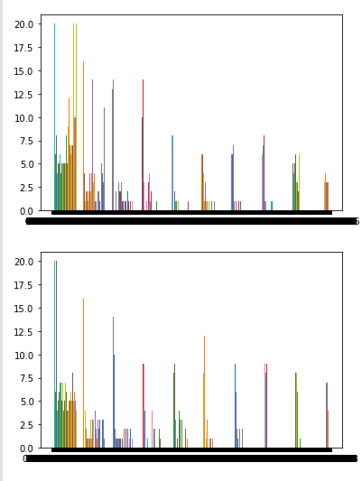
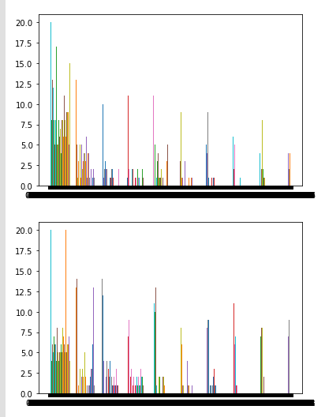

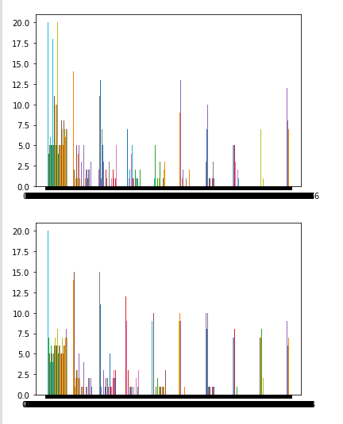

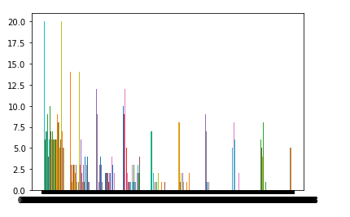

2)
- at bins = 5,

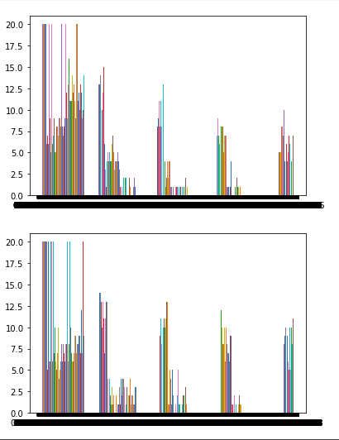
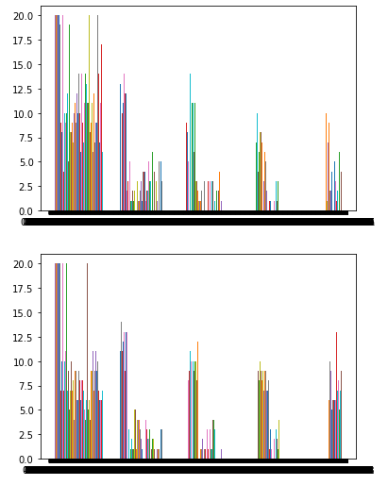

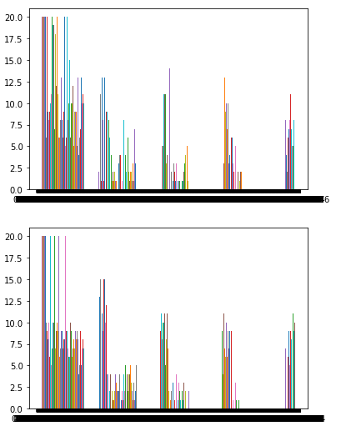
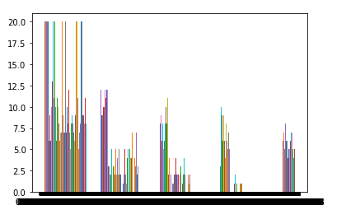

- at bins = 10,

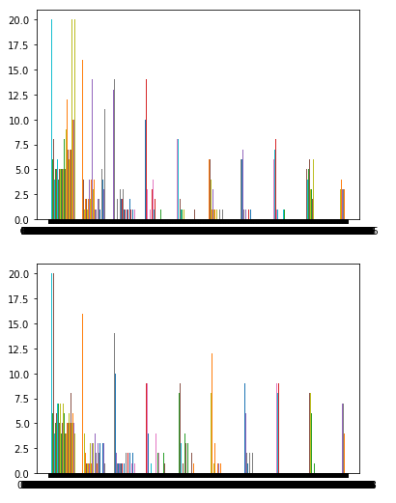
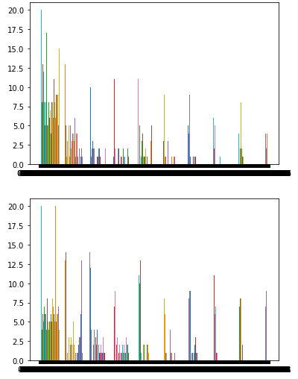

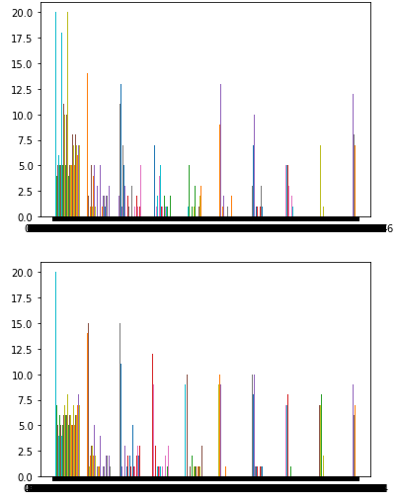
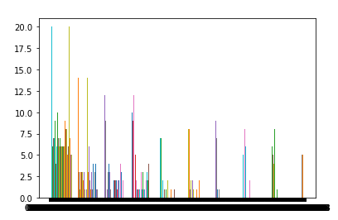

2)Boxplots:

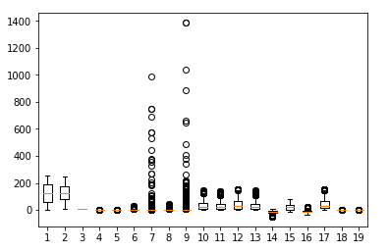

3)Correlation Matrix:

1)dxd symmetric matrix(d=19):
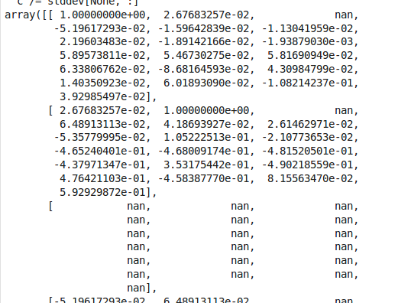
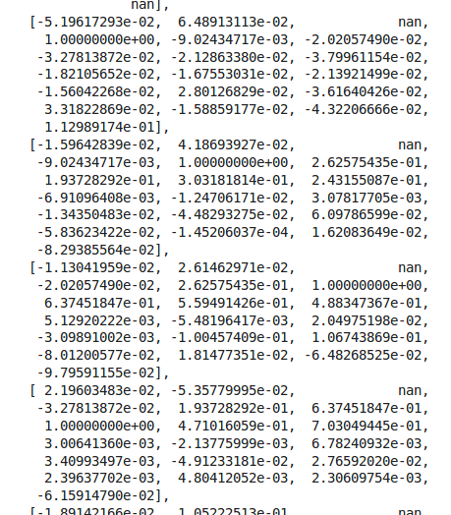

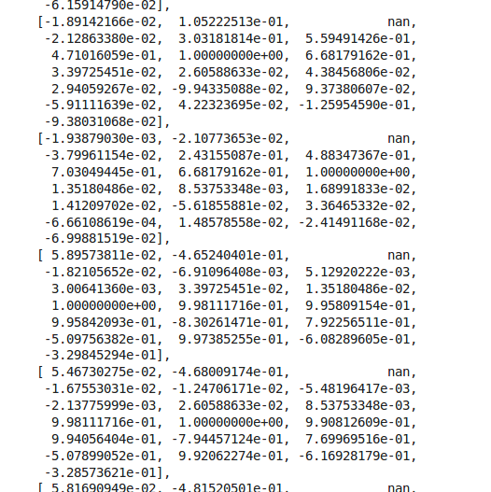
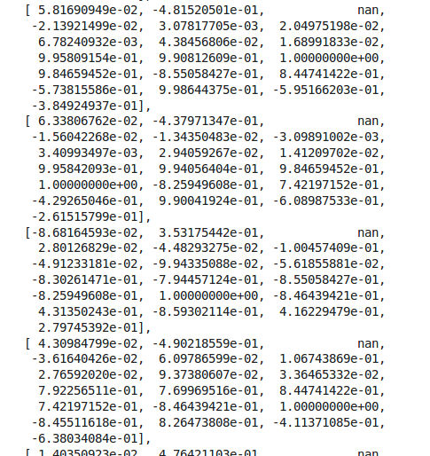

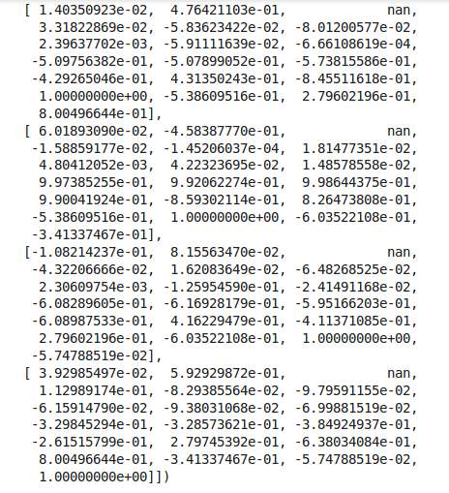

2)
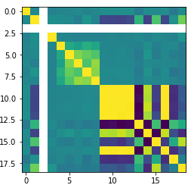

2)Preprocessing:

1)Normalization:

1)Min-max scaler:

- normalizedMinmaxList:

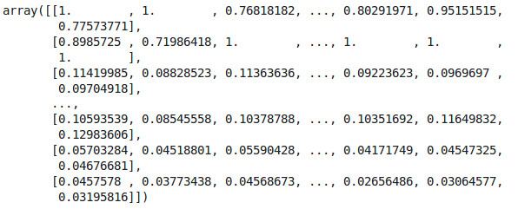
- Histograms before and after normalization:
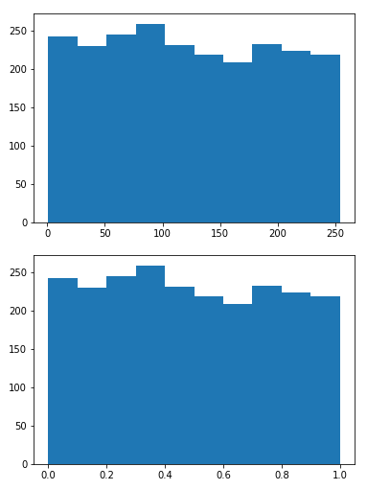

- Boxplots before and after normalization:
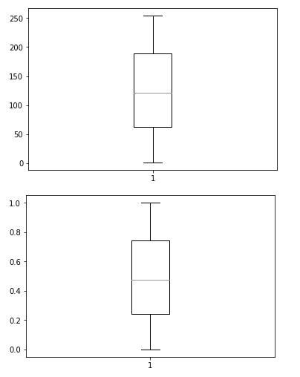

2)Z-score:

- normalizedZscoreList:
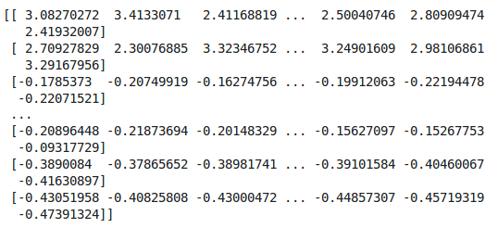

- Histograms before and after normalization:
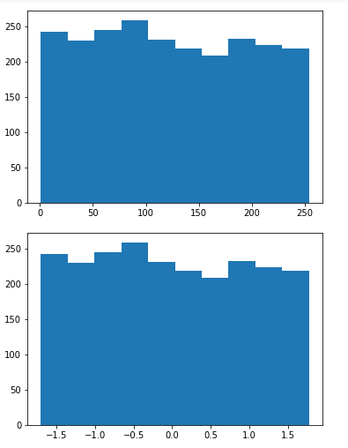

- Boxplots before and after normalization:
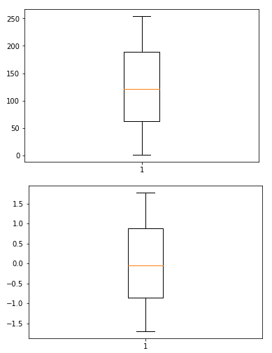

1)Dimensionality reduction:

1)Feature Projection:

- Variance_ratio after applying PCA with:

components = 19,

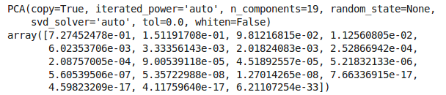
components = 10,

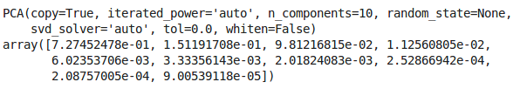
components = 5,

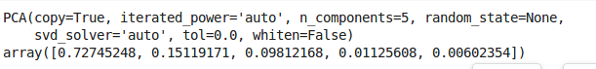
components = 2,

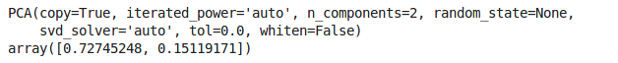

- Correlation matrix of your dataset after applying PCA:

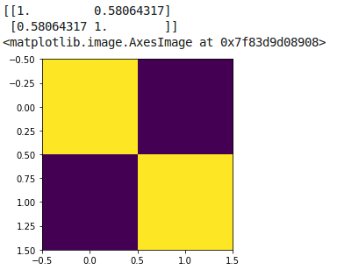

2)Feature selection:

- Pvalues after applying SelectKBest:

- Scores after applying SelectKBest:

- Correlation matrix of your dataset after applying SelectKBest:

